Adverb

🔵 What is an Adverb?
# Source: AI Source: Provided by: [Data Path: Persons Table -> ID Column: 1, Name_En Column: Motasem Essam] -> From: [Chatgpt (GPT-4-turbo)] on [7/24/2025]
An adverb is a word that modifies (describes or gives more information about) a verb, adjective, another adverb, or even a whole sentence.
It tells how, when, where, how often, or to what extent something happens.

📘 Definition:
# Source: AI Source: Provided by: [Data Path: Persons Table -> ID Column: 1, Name_En Column: Motasem Essam] -> From: [Chatgpt (GPT-4-turbo)] on [7/24/2025]
An adverb is a word that gives more information about a verb, adjective, another adverb, or a sentence — often answering questions like how, when, where, or how much.

🧠 Examples of Adverbs:
# Source: AI Source: Provided by: [Data Path: Persons Table -> ID Column: 1, Name_En Column: Motasem Essam] -> From: [Chatgpt (GPT-4-turbo)] on [7/24/2025]
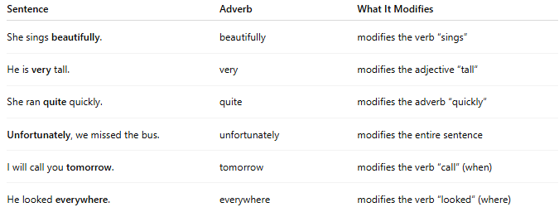
Sentence | Adverb | What It Modifies
She sings beautifully. | beautifully | modifies the verb “sings”
He is very tall. | very | modifies the adjective “tall”
She ran quite quickly. | quite | modifies the adverb “quickly”
Unfortunately, we missed the bus. | unfortunately | modifies the entire sentence
I will call you tomorrow. | tomorrow | modifies the verb “call” (when)
He looked everywhere. | everywhere | modifies the verb “looked” (where)

✳️ Types of Adverbs:
# Source: AI Source: Provided by: [Data Path: Persons Table -> ID Column: 1, Name_En Column: Motasem Essam] -> From: [Chatgpt (GPT-4-turbo)] on [7/24/2025]
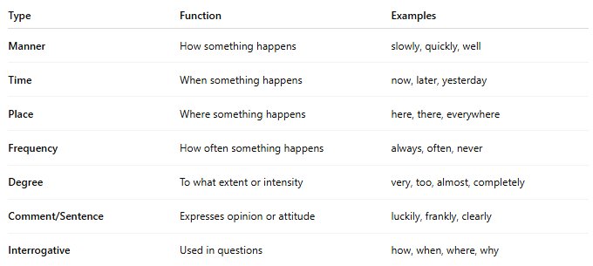
Type | Function | Examples
Manner | How something happens | slowly, quickly, well
Time | When something happens | now, later, yesterday
Place | Where something happens | here, there, everywhere
Frequency | How often something happens | always, often, never
Degree | To what extent or intensity | very, too, almost, completely
Comment/Sentence | Expresses opinion or attitude | luckily, frankly, clearly
Interrogative | Used in questions | how, when, where, why

⚠️ Adverbs vs Adjectives:
# Source: AI Source: Provided by: [Data Path: Persons Table -> ID Column: 1, Name_En Column: Motasem Essam] -> From: [Chatgpt (GPT-4-turbo)] on [7/24/2025]
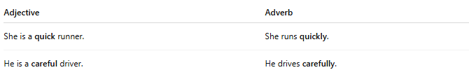

Adjective | Adverb
She is a quick runner. | She runs quickly.
He is a careful driver. | He drives carefully.

✅ Summary:
# Source: AI Source: Provided by: [Data Path: Persons Table -> ID Column: 1, Name_En Column: Motasem Essam] -> From: [Chatgpt (GPT-4-turbo)] on [7/24/2025]
An adverb tells us how, when, where, how often, or to what extent something happens.

